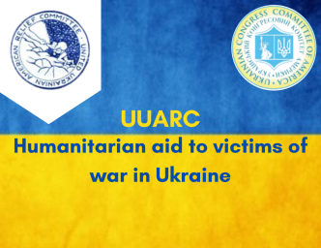

Dear Donors,
You can make a difference by donating to UUARC's mission of providing humanitarian aid to the victims of war in Ukraine 2022
United Ukrainian American Relief Committee, Inc (UUARC) was established in 1944 and started fulfilling its mission of “Brother-to-Brother” by assisting Ukrainians in refugee camps during and after WWII, and then helping to resettle more than 70,000 of these refugees in the United States.
Since its beginning, UUARC has endeavored to provide aid where the need is the greatest, as well as assisted countless Ukrainians throughout the world.
Currently UUARC is raising funds to provide humanitarian aid to the victims of war in Ukraine after further invasion of Russia onto Ukrainian soil and conflict escalation.
With millions of potential victims in Ukraine, UUARC is fundraising to provide vital medical supplies to victims, care for the injured and refugees, as well as shelter and food to those affected.
UUARC is working closely with UCCA, UWC, US Aid, and the Ukrainian Embassy in the coordination of aid.
Donations can be made directly to United Ukrainian American Relief Committee, Inc. 1206 Cottman Avenue, Philadelphia, PA 19111
or at www.uuarc.org ‘Donate Now’
or Go Fund Me https://gofund.me/d17cab63
UUARC is a non-profit organization recognized by the IRS under Article 501(c)3, every gift is tax-deductible and the donor receives an acknowledgement for the donation.

